# Required Components

|  |  |
| --- | --- |
|  | |
| **BOM**   1. Transmitter Lid 2. Transmitter Base 3. Transmitter Cover x2 4. Transmitter Button x2 5. M3 screw x8 6. Double Sided Velcro 7. Circuit Playground Bluefruit 8. LiPo Battery x2 9. Battery Charger 10. Slide Switch 11. Receiver Base 12. Receiver Lid 13. ItsyBitsy nrf52408 14. Battery Backpack 15. 3.5mm mono jack 16. Protoboard | 1. Female header pins 2. M2 Screw x8 3. Toggle switch 4. 5V relay 5. Potentiometer x2 6. Breadboard wire 7. Wire |

# Required Tools

* Soldering iron
* Flush Cutters
* Wire stripper
* Solder
* Electrical Tape
* Screwdriver
* Superglue
* Allen Keys

# Required Personal Protective Equipment (PPE)

* Safety Glasses

# Assembly Instructions

## Transmitter

## Step 1

Take two 5cm pieces of wire and strip 1cm from each end.

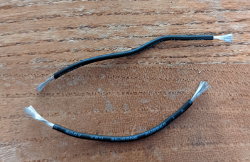

## Step 2

Cut the black wire on one battery 4cm from the JST connector and strip 1cm on each end of the cut.

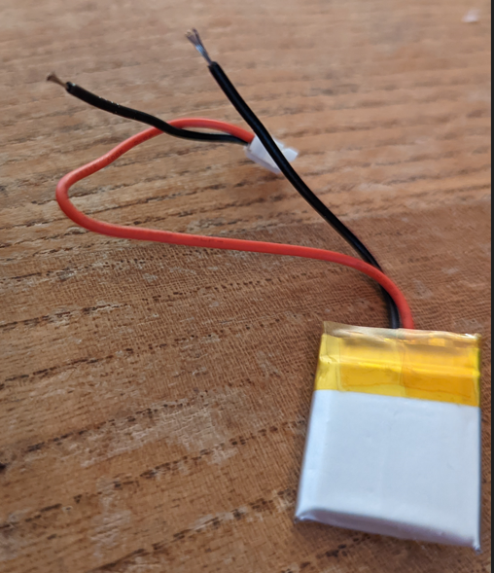

## Step 3

Solder the wires from step 1 onto each end of the stripped cut from step 2 and cover the soldered joints with electrical tape.

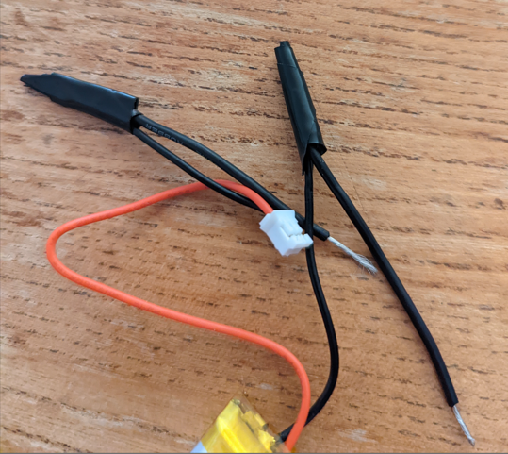

## Step 4

Solder the remaining two ends of the wire to the middle and one side terminal of the slide switch. Either side terminal will work.

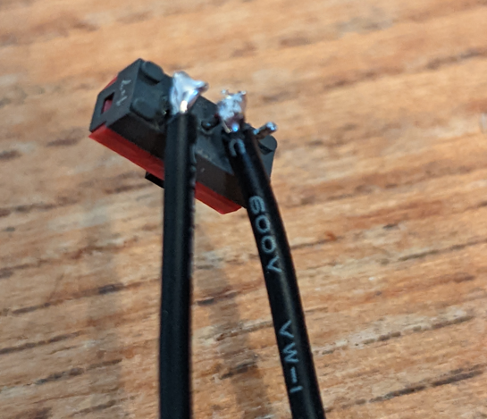

## Step 5

Cut two lengths of double sided hook and loop fastener, roughly 10 and 8 inches long. Take the longer piece and weave it through the aligned slot in the base as shown in the picture, with the soft side facing away from the base.

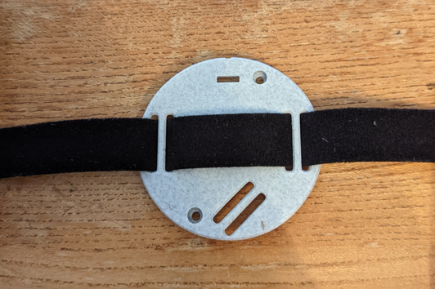

## Step 6

Take the smaller piece of hook and loop fastener and weave it through the angled slot with the soft side facing away from the base. Align it as shown in the picture.

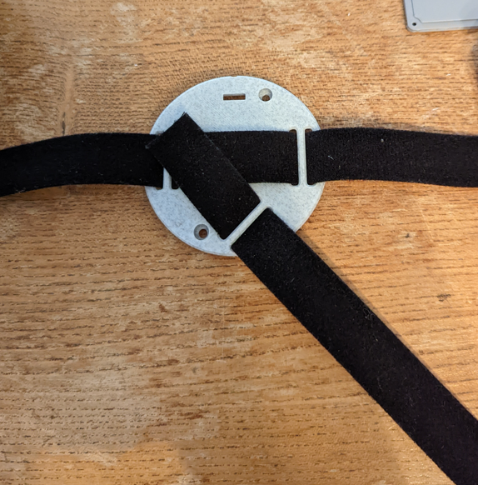

## Step 7

Place the battery in the base and route the wires as shown in the picture. Secure the switch in the base with a dab of superglue.

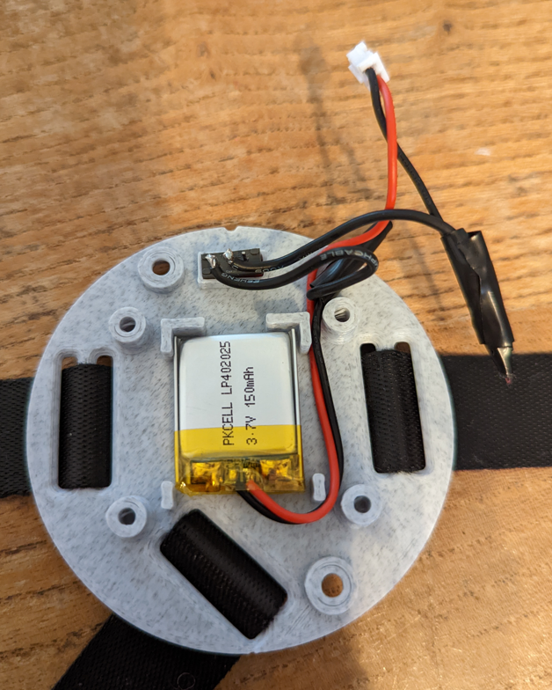

## Step 8

Connect the Circuit Playground to the computer and upload the central_bleuartInstrucable0424.ino file to it.

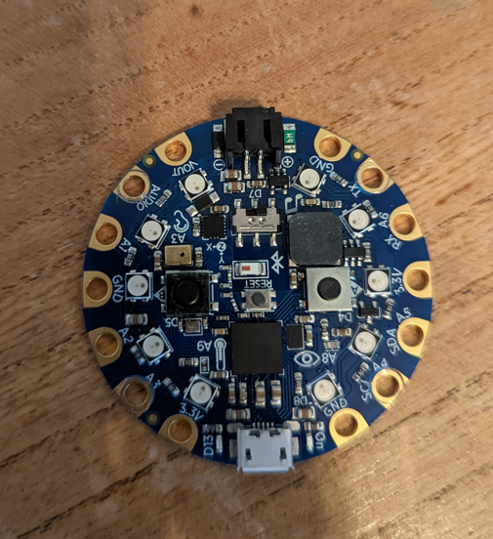

## Step 9

Place the circuit playground on the four posts around the battery holder and use M3 screws to attach it onto each post.

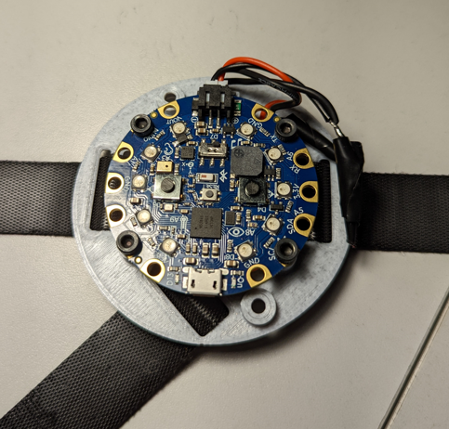

## Step 10

Take the lid and place it upside down. Insert both covers into the slots by the ports, and both buttons in the holes in the centre.

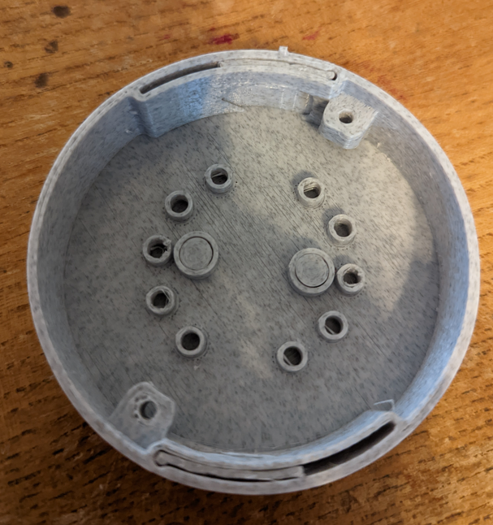

## Step 11

Place the base assembly onto the lid, using the aligning peg to get the orientation correct. Secure the base onto the lid with two M3 screws.

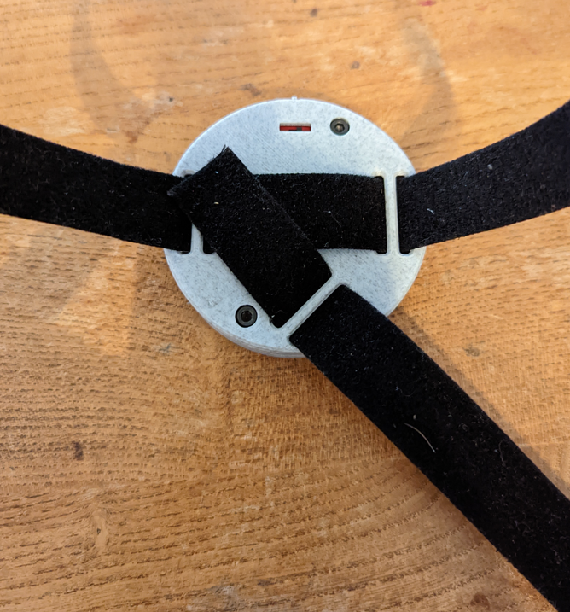

## Receiver

## Step 1

Cut two 6cm pieces of wire and strip 1cm from each end. Solder one end of each wire to the 3.5mm mono jack as shown in the picture. Connect the other ends to the NO and COM terminals on the relay.

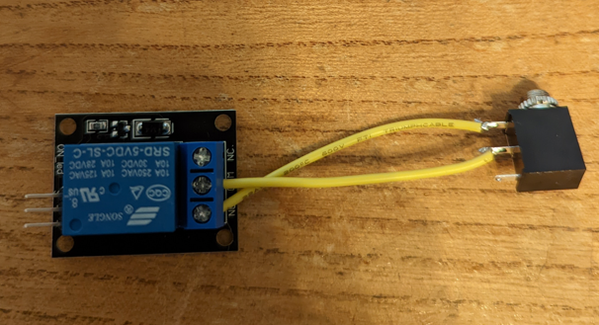

## Step 2

Cut 2 lengths of female headers 14 pins long to match the pins on the ItsyBitsy microcontroller. Attach the headers to the ItsyBitsy and place the headers onto the protoboard as shown in the picture. One row of headers will be in the row labeled 03, and the other will be in the row labeled 09.

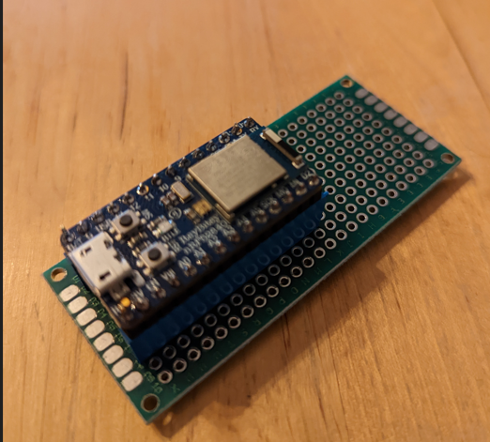 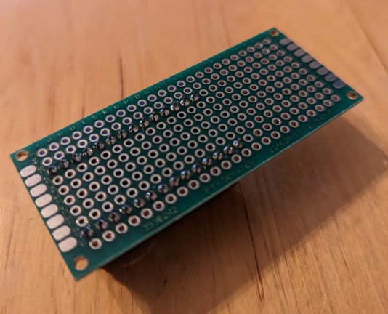

## Step 3

Cut a 3-pin long section of female header and solder it to the protoboard as shown in the photo. Insert the battery backpack.

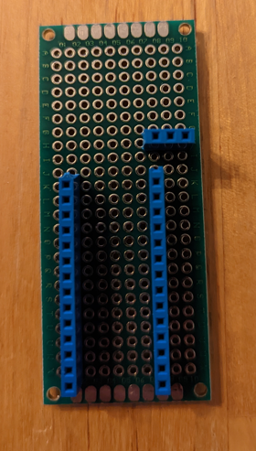

## Step 4

Cut 4 10cm pieces of wire and strip 1cm from each end. Use 2 of these pieces to connect the 5V pin on the battery backpack header to the USB pin on the ItsyBitsy header, and the G pin on the battery backpack header to the G pin on the ItsyBitsy header

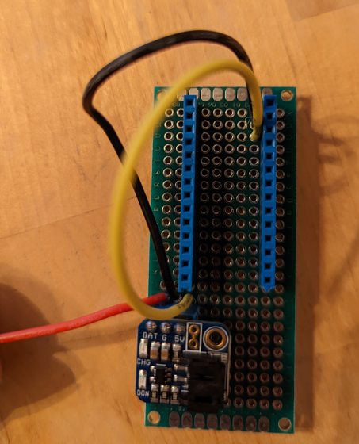

## Step 5

Use the remaining two wires and solder them to the centre and right pin of the toggle switch, as seen in the below picture. Solder the other two ends to connect the BAT pin on the battery pack header to the BAT pin on the ItsyBitsy header.

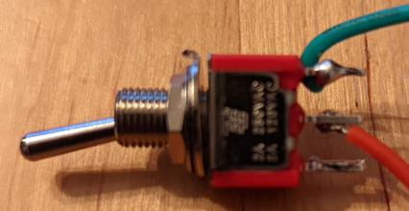

## Step 6

Cut 6 15cm pieces of wire and solder the end of each to every pin on the two potentiometers as in the attached photo. Take the right wires on both potentiometers when viewed from the knob with the pins facing down, and connect them to the G pin on the ItsyBitsy header, and both left wires to the 3V pin on the ItsyBitsy header. Connect the middle wire on one potentiometer to the A1 pin on the ItsyBitsy header, and the other to the A2 pin.

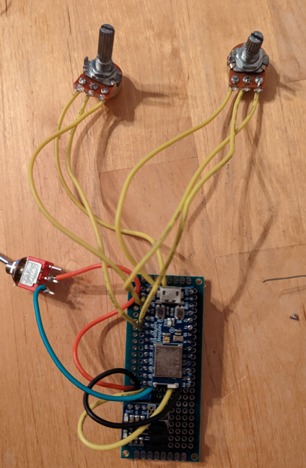

## Step 7

Using breadboard wire, connect the “–” pin of the relay to the G pin of the ItsyBitsy header, the “+” pin to the battery pin, and the “S” pin to the 9 pin.

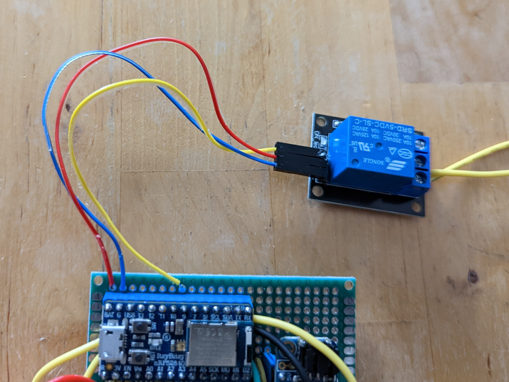

## Step 8

Plug the battery into the battery backpack and screw the protoboard into the base using 4 M2 screws, such that the USB port on the microcontroller lines up with the oval hole in the enclosure, as shown in the picture.

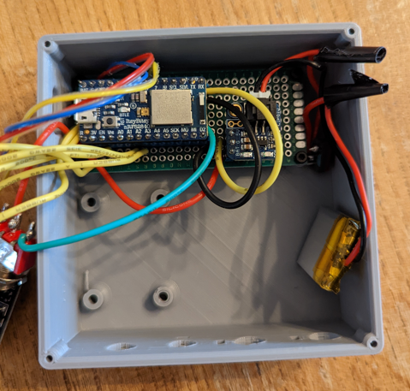

## Step 9

Remove the retaining nuts on both potentiometers and the toggle switch. Insert the potentiometer connected to A2 through the hole labeled Duration, orienting it with the tab, and securing it in place with the retaining nut. Repeat this with the potentiometer connected to A1 and the Delay hole, and the toggle switch and the ON/OFF hole.

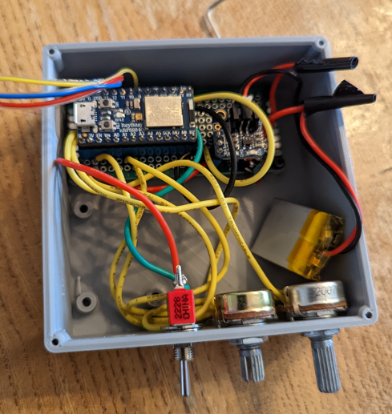

## Step 10

Remove the retaining nut from the 3.5mm jack. Insert it through the last hole in the base, aligning the relay with the four posts on the base. Use two M3 screws on the rear posts to hold it in place. Secure the jack in place with the retaining nut.

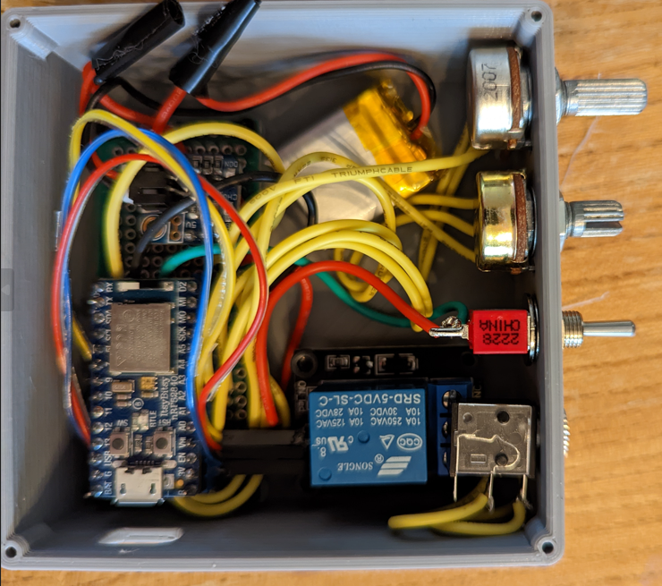

## Step 11

Tuck the battery into the case and secure the lid with 4 M2 screws.

